**Regular**

**Expression**

**(Reg.Ex.=Regex)**

A sequence of characters according to a pattern (repeated order of string) is known as regex.

In other words string is search pattern of strings.

If we want to used a group of string according to a particular pattern then we have to use Regular expression. Such as **emailed and phone number** must have special pattern.

Ex. Emailed,phonenumber,name etc.

**When and why we use Regular expression?**

**1.**Vaidate the data on the behalf of specific rule such as email id,phone number etc

2. Search the character,

3. Language processing.

4. Compiler designing ,TOC , AI etc.

5.translators,parser,assemblers,interpreters etc.

6. we can develop the digital circuit(more-melay machine),communication protocols etc.

Note:-Most of the validation framework developed on the behalf of regular expression like jquery , angularjs , struts , spring etc .

All the Regular Expression classes and interfaces found into java.util.regex package.

Pattern class is used to create the String Pattern.

public static Pattern compile(String str);

Method Pattern class:

Public Mathcer matcher(String matcher);

Method of Mathcer class.

start()->return the start index of matcher string

end()->return the end index of matcher string

group()->return the matches string of from matcher.

Find()->return true if string is matched

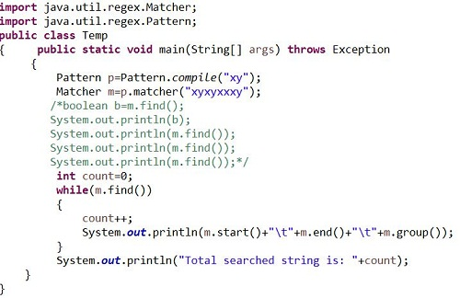

**Character Classes:**

[abc]=either a or b or c

[^abc]=except a or b or c

[a-z]=any lower case letter from ato z

[A-Z]=any upper case letter from A to Z

[0-9]=any digit from 0 to 9

[a-zA-Z]= ato z and A to Z

[0-9a-zA-Z]=0 to 9 and a to z and A to Z

[^0-9a-zA-Z]= except 0 to 9 and a to z and A to Z

[a-dm-p]=a to d or m to p

|  |  |
| --- | --- |
| **Character classes** | |
| [abc] | a, b, or c (simple class) |
| [^abc] | Any character except a, b, or c (negation) |
| [a-zA-Z] | a through z or A through Z, inclusive (range) |
| [a-d[m-p]] | a through d, or m through p: [a-dm-p] (union) |
| [a-z&&[def]] | d, e, or f (intersection) |
| [a-z&&[^bc]] | a through z, except for b and c: [ad-z] (subtraction) |
| [a-z&&[^m-p]] | a through z, and not m through p: [a-lq-z](subtraction) |

|  |  |
| --- | --- |
| **Predefined Character classes** | |
| . | Any character (may or may not match [line terminators](https://docs.oracle.com/javase/8/docs/api/java/util/regex/Pattern.html#lt)) |
| \d | A digit: [0-9]=any digit 0 to 9 |
| \D | A non-digit: [^0-9]=except digit means any characers. |
|  |  |
|  |  |
| \s | A whitespace character: [ \t\n\x0B\f\r]=space character |
| \S | A non-whitespace character: [^\s]=except space character |
|  |  |
|  |  |
| \w | A word character: [a-zA-Z_0-9]=alphanumeric characters. |
| \W | A non-word character: [^\w]=special characters |

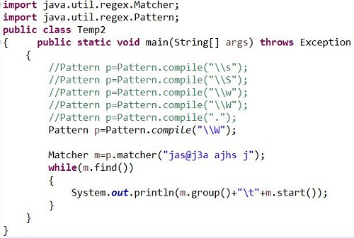

Quantifiers:

1. a=only single a
2. a+=any number of a’s
3. a*=any number of a’s including 0 number of a’s
4. a?=at most one a’s

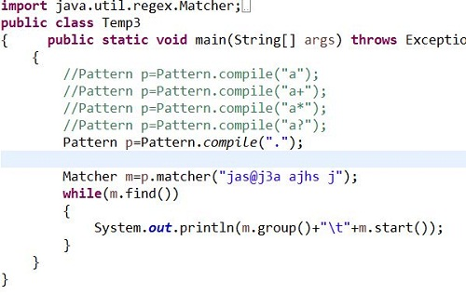

How to split()->

Split() of String class.

StringTokenizer class.

How to validate the phonenumber. Using shorest form.

[6789][0-9][ 0-9][ 0-9][ 0-9][ 0-9][ 0-9][ 0-9][ 0-9][ 0-9]

[6-9][0-9]{9}

How to validate 10 digit and 11 digit numbers.

0?[6-9][0-9]{9}

How to validate the 10 digit,11 digit and 12 digit phone number.

(0|91)?[6-9][0-9]{9}

How to validate the email id?

[a-zA-Z0-9][a-zA-Z0-9_.][*@[a-zA-Z0-9]([.][a-zA-Z]+)](mailto:*@[a-zA-Z0-9]([.][a-zA-Z]+))+

How to validate [javahubcare@javahub.com](mailto:javahubcare@javahub.com)

[a-zA-Z0-9][a-zA-Z0-9_.]*@javahub[.]com